|  |  |  |  |  |
| --- | --- | --- | --- | --- |
| EASY GRADE | | | | |
|  |  | | |  |
| COMPLETION PROGRESS | | | | |
|  | | Manual |  | |

TABLE OF CONTENTS

marking standards 3

how to access 4

how to grade 6

EMAIL NOTIFICATIONS CONFIGURATION 7

Exception handling 8

# marking standards

Remember below color guide while marking

* Dark Green Box:Activity Completion / Compliance.
* Light Green Box: Activity submitted for marking.
* Dark Blue: Activity not completed, not started, not attempted
* Red: Activity not completed/ not compliance

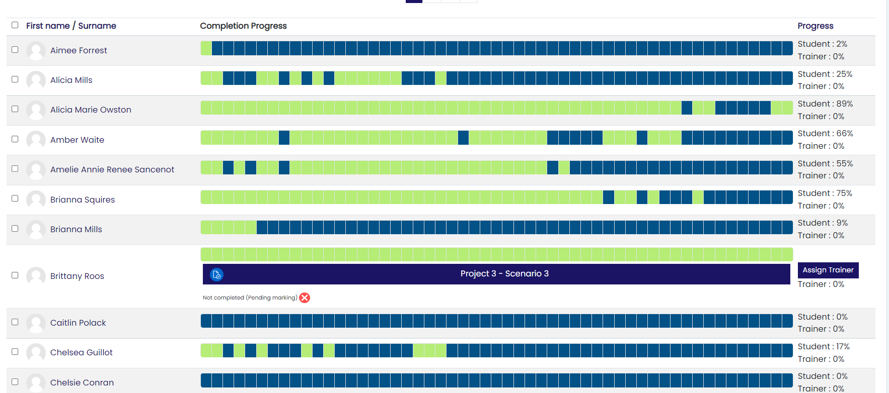

Note: GRADE could be 0(Zero) OR 1(One)

# how to access

Easy Grading development for completion progress

* Admin can check all students progress from right hand slider.
* Trainer can check their course all students progress from right hand slider.
* Student can check their course progress from right hand slider.

STEP 1 (SLIDER - RIGHT HAND SIDE IN CLUSTER):

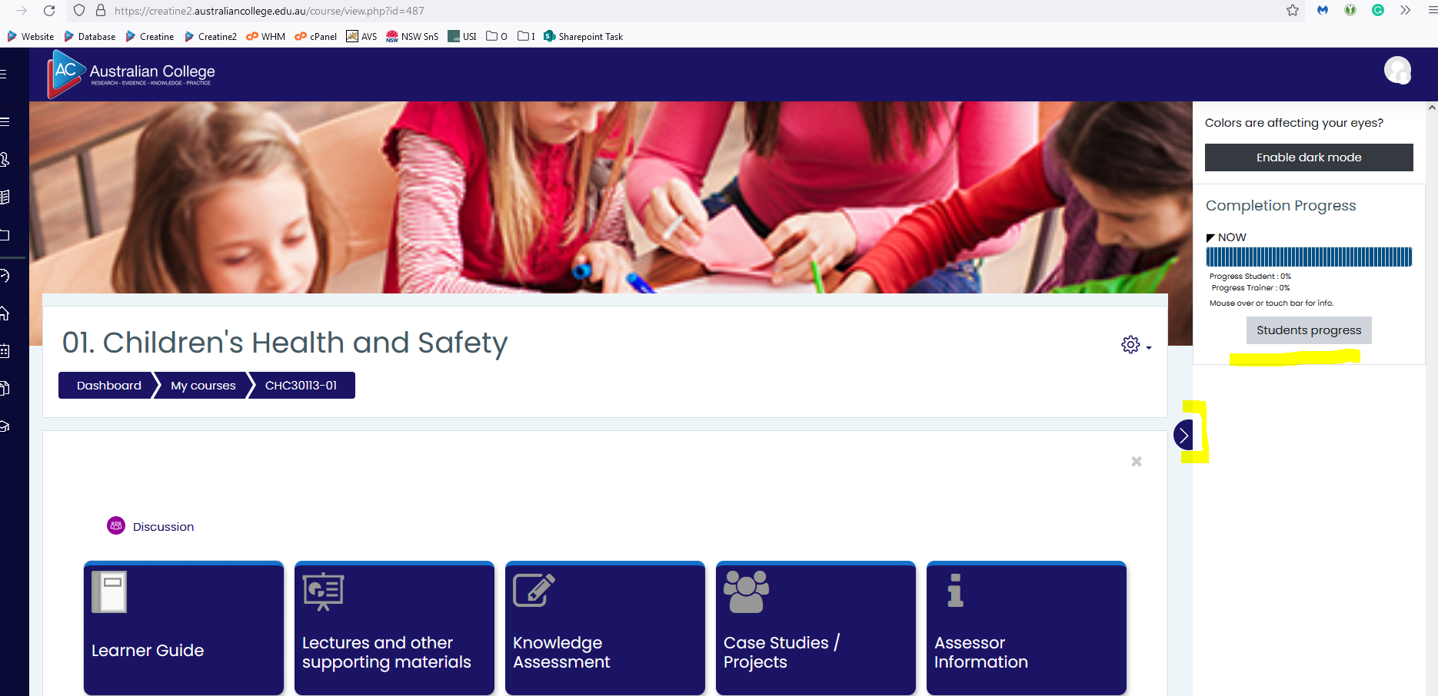

**STUDENT VIEW:** Submit All Assessments button visible if student progress > 85%

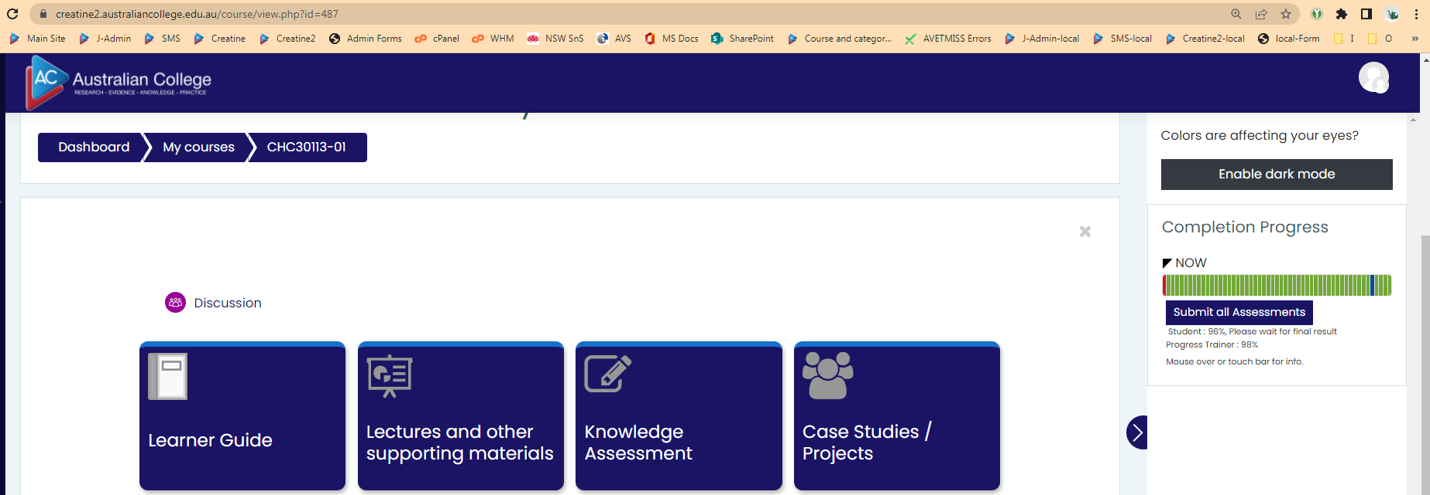

**STEP 2 (ADMIN VIEW):** Assign Trainer button visible if student progress > 90%.

Send email notification to trainer and admin about student ready for assessment marking



**STEP 2 (TRAINER VIEW):** Release result button visible if trainer progress > 80%.

Send email notification to student and admin about student assessment marking completed

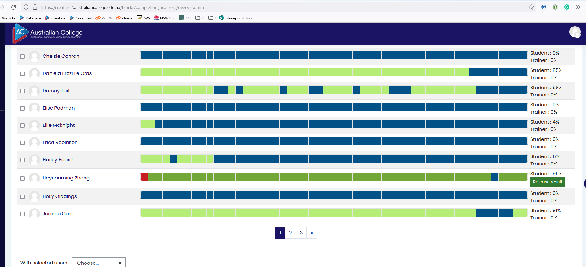

# how to grade

Highlight any activity to view activity name and status.

1. Click color bar to view activity in the same tab for grading.
2. Click below blue activity name button to view activity in new tab for grading. Recommended
3. Complete marking on new page (Mark, Save, Close page) Step 2, don’t override marks.



# EMAIL NOTIFICATIONS CONFIGURATION

Email notifications:

1. All AC Staff /Course Manager & trainers will receive notification of Assign Trainer / Submit all assessments.
2. Student & all AC Staff /Course will receive notification of Release Result.

# Exception handling

Pages should ignore.

* Dark Blue: Activity not completed, not started, not attempted

1. Admin can view all student quiz/assignment submissions.
2. Trainer can view all student quiz/assignment submission.
3. Student can view a page to attempt quiz/assignment.

Ignore below pages while grading.

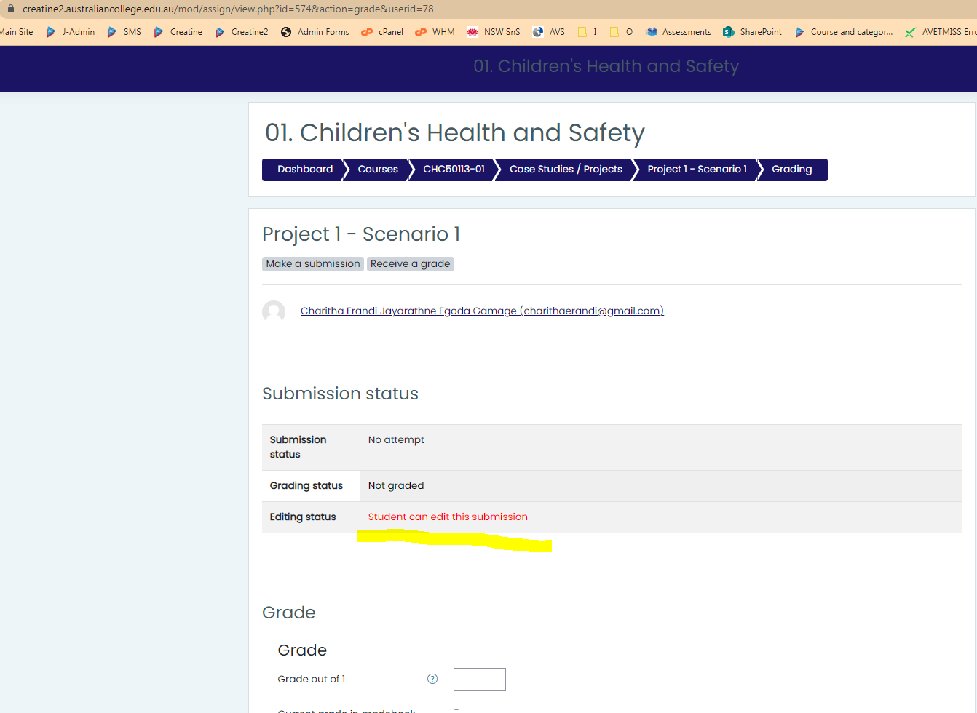

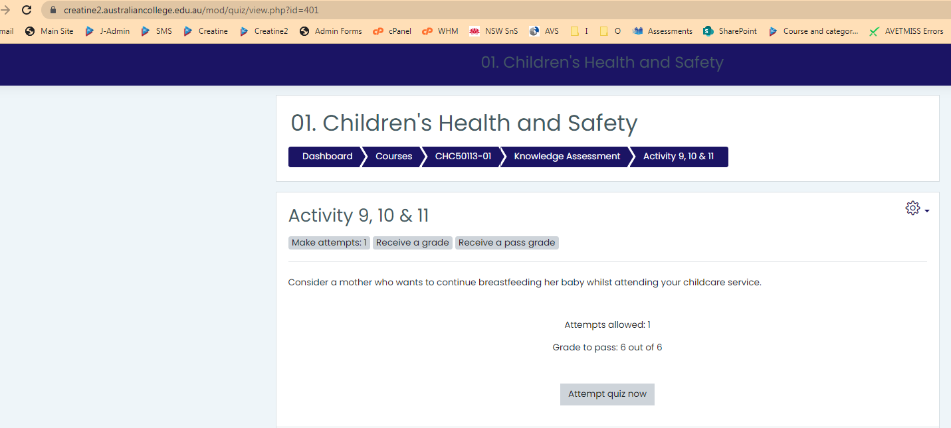

THANK YOU

Should you have any questions, please do not hesitate to contact IT department:

**Syed Nayab Bukhari**

[Syed@australiancollege.edu.au](mailto:Syed@australiancollege.edu.au)

[Bec_dir@yahoo.com](mailto:Bec_dir@yahoo.com)